

System Analysis and Design

Final Assignment

School of Software Class 2021 Group T13

# I. **The design approach and the contribution of each team member**

The main system analysis and design is done with UML tools using an object-oriented design strategy.

1. Define the purpose of the design.

2. Analyse what functions the system needs to perform in order to achieve these aims, and on this basis draw use case diagrams and write use case statutes.

3. Draw a class diagram and analyse the relationship between the classes.

4. Draw a sequence diagram.

5. Determine the design of the database based on the identified classes and the links between classes.

6. Complete the general design of each interface.

Based on the design work, the team members were divided as follows:

Team leader: 朱家顺

1. The design approach and the contribution of each team member: 朱家顺
2. Design objectives and principles: 朱家顺
3. Needs Analysis: 苏琪超
4. Use Case Modelling: 翟启发, 苏沛泽
5. User interface: 朱家顺, 蔡宏天
6. Class picture: 李亦语
7. Sequential picture: 陈俊言, 蔡宏天
8. Persistence data ER diagram: 苏沛泽, 公令适
9. Application deployment diagram: 林志超, 张长兴

# II. design objectives and principles

Design Objective:

Design an online web application that can run on Windows, with a registration period that allows provincial leagues to register for tournaments by entering provincial league information, selecting tournament categories and levels during the open registration period, connect the designed system to the two banking systems used by the provinces and conference organisers to process payments and refunds of registration fees, and provide functionality that allows provincial leagues to readily print registration records for participating tournaments.

Design principles:

Simplicity: The user interface is designed to be simple and intuitive, so that the league can easily understand and use the system without the need for cumbersome training.

Data accuracy: data validation and verification are carried out to ensure the accuracy and completeness of registration information.

Integration: the design system is connected to two banking systems to enable payment of registration fees and refund operations.

Searchability: Provides a search function that enables the registration administration of sports competition organisers to search for matches registered in a provincial league (category and level) and which provincial leagues have registered a particular match (category and level).

Scalability: Design a scalable system that can easily add new competition categories, levels and features to accommodate changing competition needs.

Data security: Appropriate security measures, such as data encryption and access control, are in place to protect sensitive information from unauthorised access and disclosure.

Efficient: design the system to achieve an efficient registration process and query response time to provide a good user experience.

Maintainability: The design system is easy to maintain and update, allowing for easy fixes and functional improvements.

Reliability: Ensures system stability and reliability, preventing data loss and system failure.

# III. Requirements captured

The registration system is available to all students in the school and students can access the 'Register for a Course' page via the login page to complete their registration for the corresponding course. At the same time, students can check and print their results records.

The school administration can search the database for information about professors, students and classes, and can also print it.

### Students are required to complete the following actions during registration:

1. Students need to provide their student ID number, name, address and the course they are taking this semester
2. Add a course
3. Delete Course

Note: ① Applications for registration should be made during the registration period;

②Adding and deleting courses will not leave any record.

### Once registration is complete students can do the following:

1. Withdraw from any course they are enrolled in
2. Checking and printing results records

Note: ① After this period, students withdraw from any course they are registered for, including withdrawal from the entire registration

(all courses), which will be awarded a grade of "W";

②Each student's grade record can be printed at any time, with possible grades of "A", "B", "C", "D ", "F", "W", "-".

### The School Registration Manager can search and print the following information.

1. Information about the professor and the courses taught
2. Student information and courses taken and awards received
3. Student information and teacher information for the class

Note: ① Awards received by students can only be checked or printed if the student has received the award.

# IV. Use case modelling

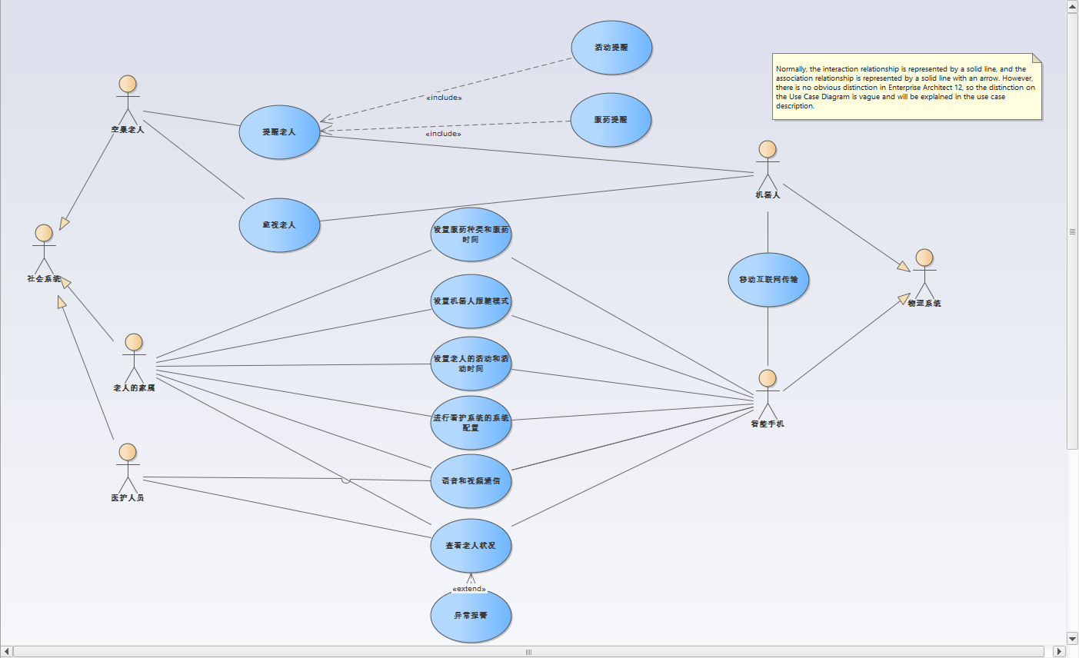

Use Case Description (Use Case Statute document)

|  |
| --- |
| Use Case A: |

|  |  |
| --- | --- |
| Use case name |  |
| Trigger events |  |
| Participants |  |
| Pre-requisites |  |
| Post-condition |  |
| Basic event flow |  |
| Alternative event streams |  |
| Extension points | N/A |
| Input data |  |
| Output data |  |
| Non-functional requirements |  |

# User Interface

## Part 1 Student Registration Management

1. Student Login

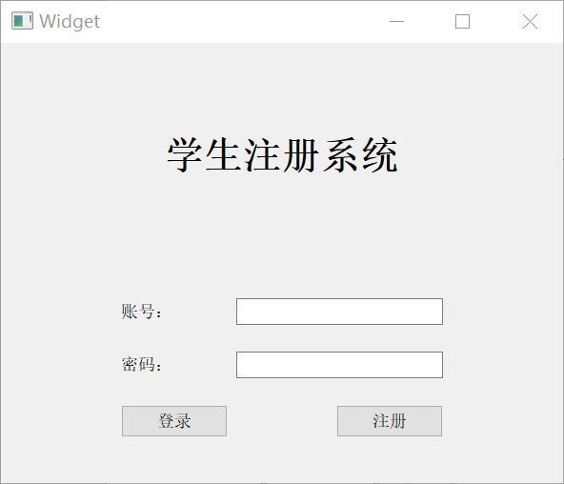

1. Registration

# VI. Class Diagram

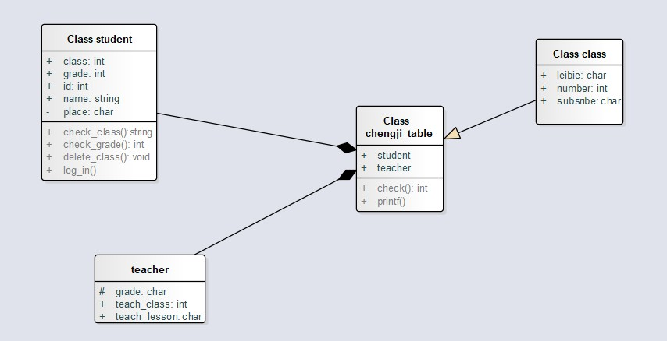

VII. Sequence diagram

1. Register for a course

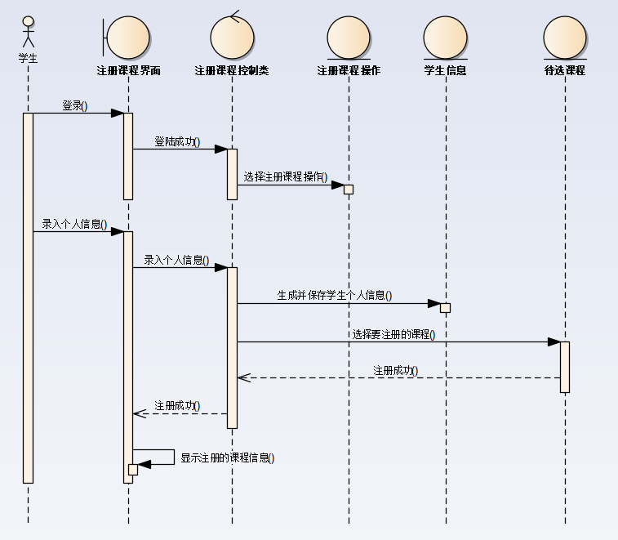

# VIII. Persistence data ER diagram (Persistence data)

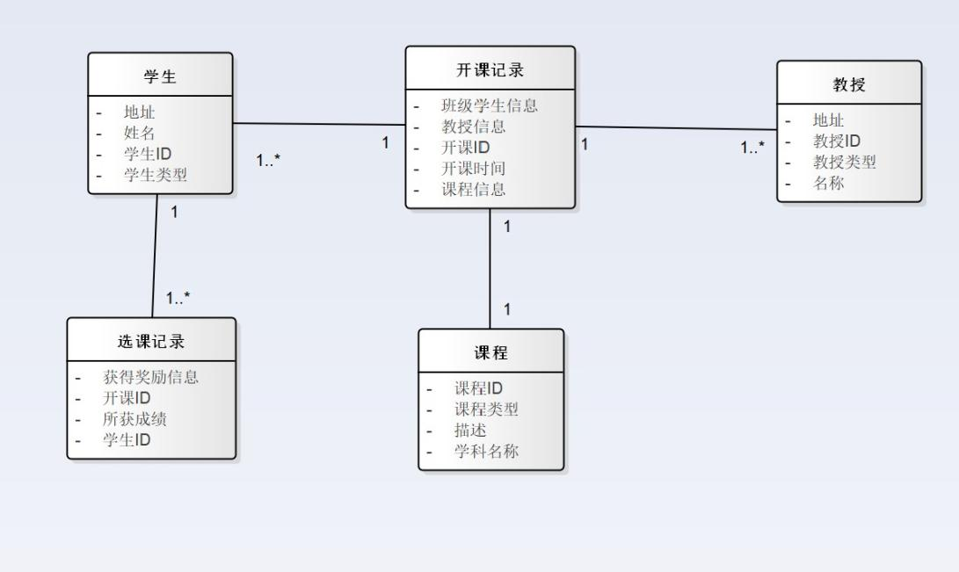

1. Students have a unique primary key Student ID
2. The professor has a unique primary key Professor ID
3. Courses have a unique master key course ID
4. The class record has a unique primary key for the class ID, a foreign key for the class student information to match the student ID, a foreign key for the course information to match the course ID and a foreign key for the professor information to match the professor ID
5. The primary key for the course selection record is the Student ID + Course ID, which is generated after the registration deadline

# IX. Application deployment diagram

# 